
Name of the Experiement : Frontend Connect – Web3.js Integration
Coding Phase : Pseudo Code/Flow Chart/Algorithm
- Start React project using npx create-react-app.
- Install web3 library.
- Create .env file with:
- In app.js:

  - Import Web3 and connect to MetaMask.
  - Load contract using ABI & address from .env.
  - Fetch storedData using contract.methods.get().call().
  - Send transaction using contract.methods.set(value).send().

5. Test the frontend by setting and getting values.
Apparatus/Software Used:
- Node.js & npm
- React.js
- Web3.js
- MetaMask
- Network: Sepolia Testnet

Testing Phase:

- Deployed SimpleStorage contract to Sepolia using Remix.
- Noted the contract address & ABI.
- Created .env file to store sensitive data.
- Connected frontend to MetaMask.
- Verified:
- Reading stored value works.
- Writing new value updates blockchain data.

Implementation Phase: Final Output (no error)

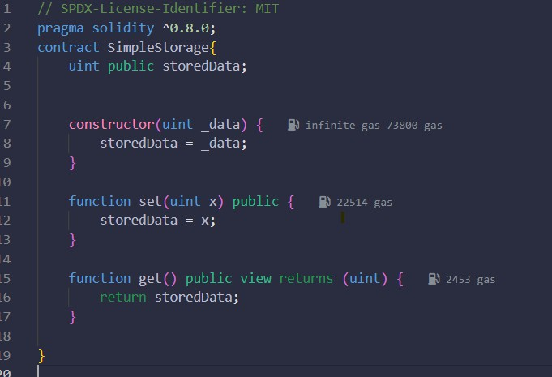
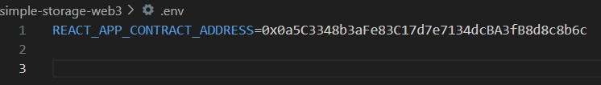
Step 1: Create a smart contract in remix IDE.

Step 2: Create a React app in VS Code.

- Open VS Code.
- Open a terminal inside of VS Code.
- Run this code (npx create-react-app simple-storage-web3).
- Then run cd simple-storage-web3.
- Then install web3 like run this code(npm install web3).

Step 3: Create a .env File.

- Write The deployed contract address from Remix or blockchain explorer.

Step 4: Connect in src/App.js

- Replace App.js with something like:

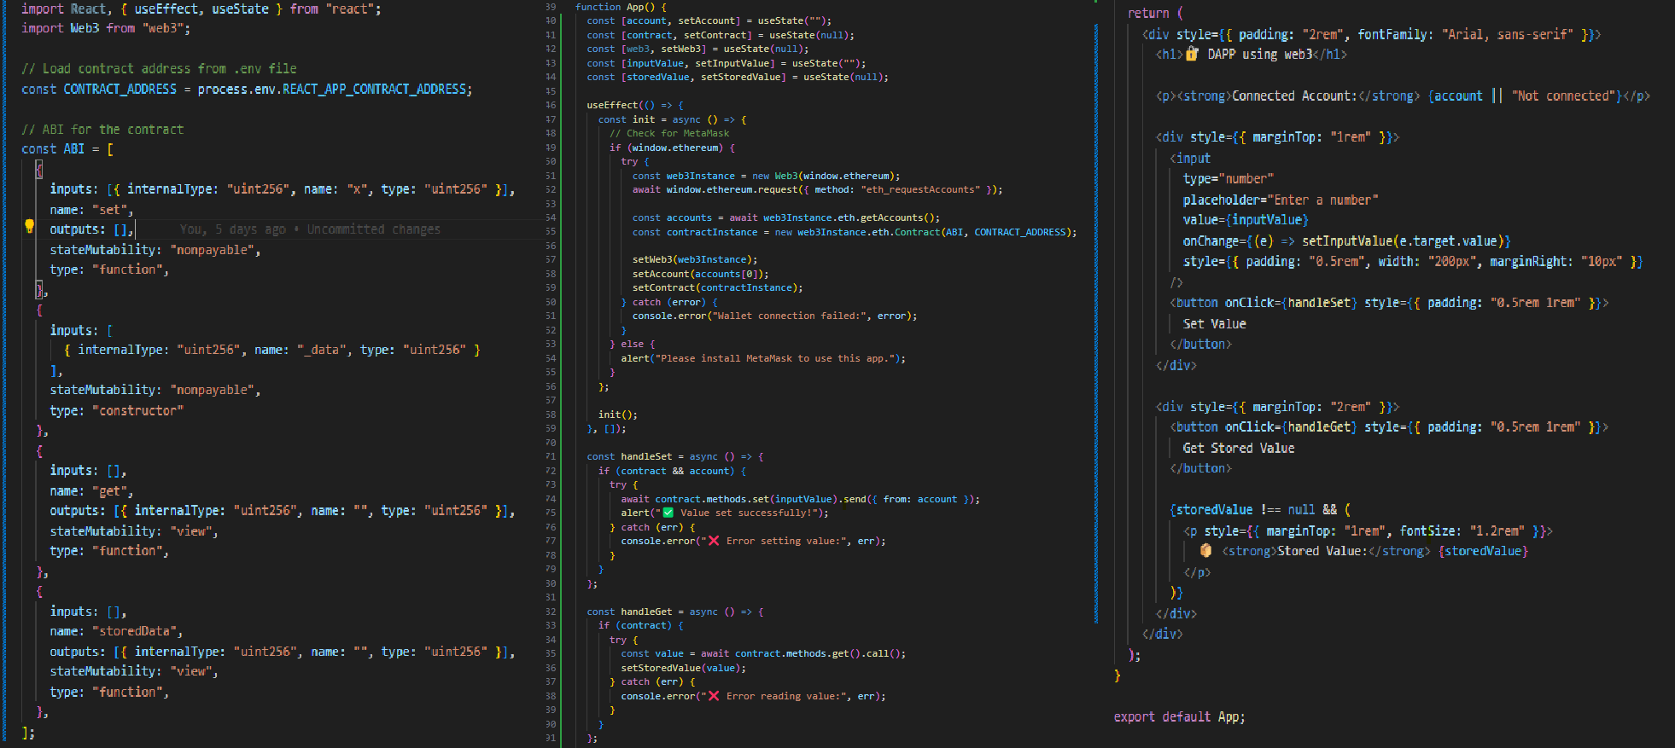
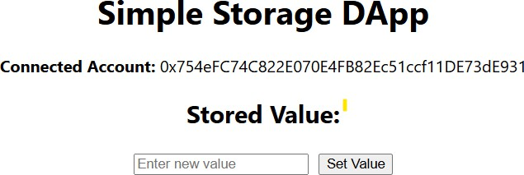
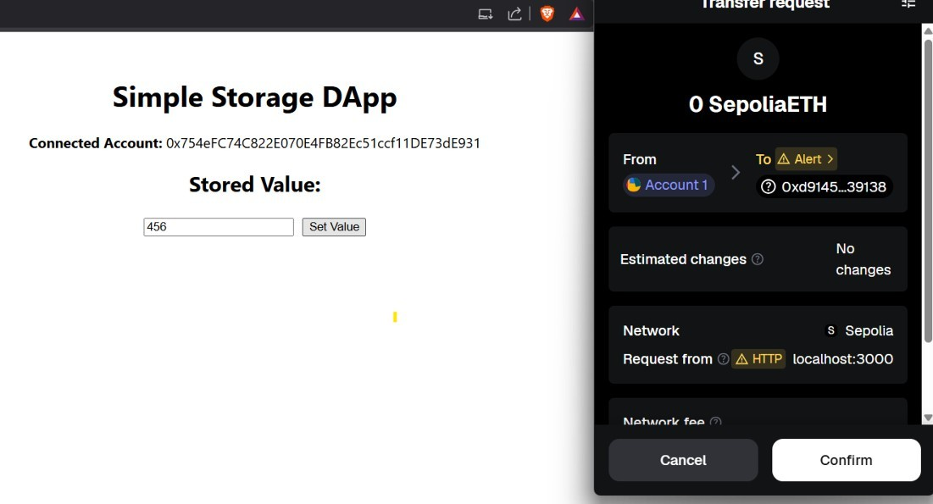

Step 5: Run the App

- In terminal: npm start

Step 6: After run this open React app at http://localhost:3000.

- Then Enter some value and set value .
- Then connect the meta mask.

Observations

- Web3.js successfully connected frontend to blockchain.
- MetaMask allowed account access and transaction confirmation.
- Updating values from frontend reflected immediately on blockchain

